1.

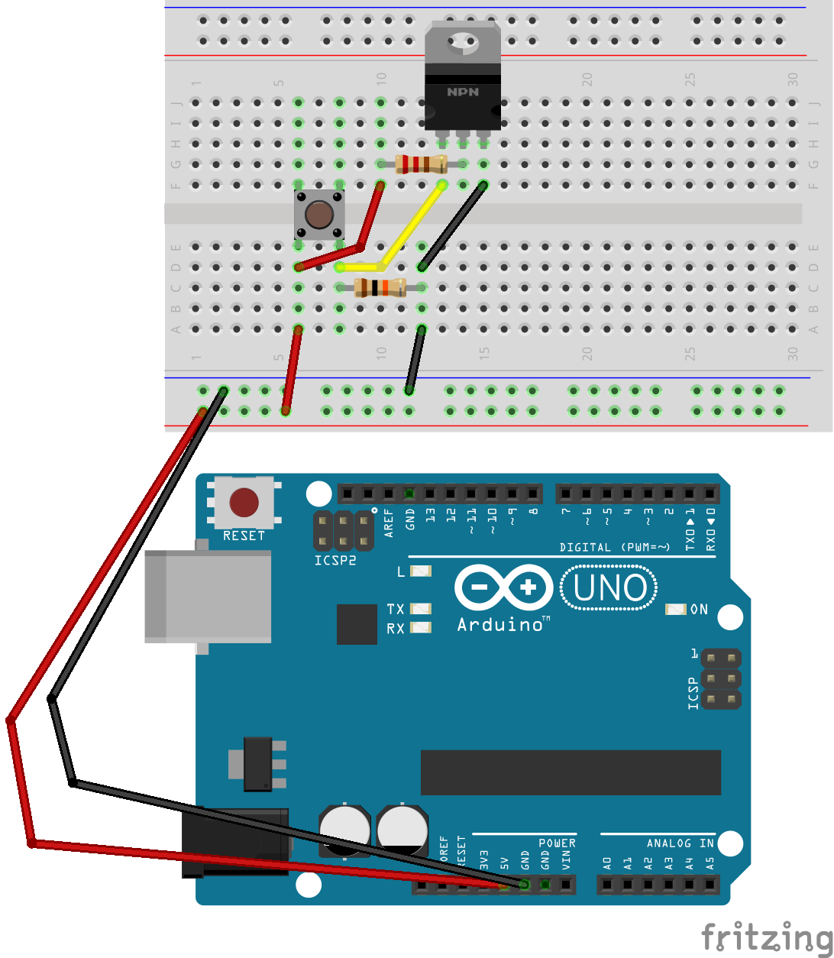

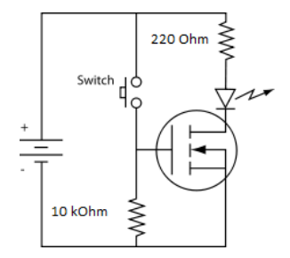

The positive electronic through 220 voltage link to drain of mosfet, and negative electronic directly link to source of mosfet and the positive electronic have switch link to gate of mosfet and through 10k voltage link to gnd. It use to manage high voltage and low voltage.